# 4. Git-HOL

I learned the following in this hands-on lab:

- Explain how to resolve merge conflicts

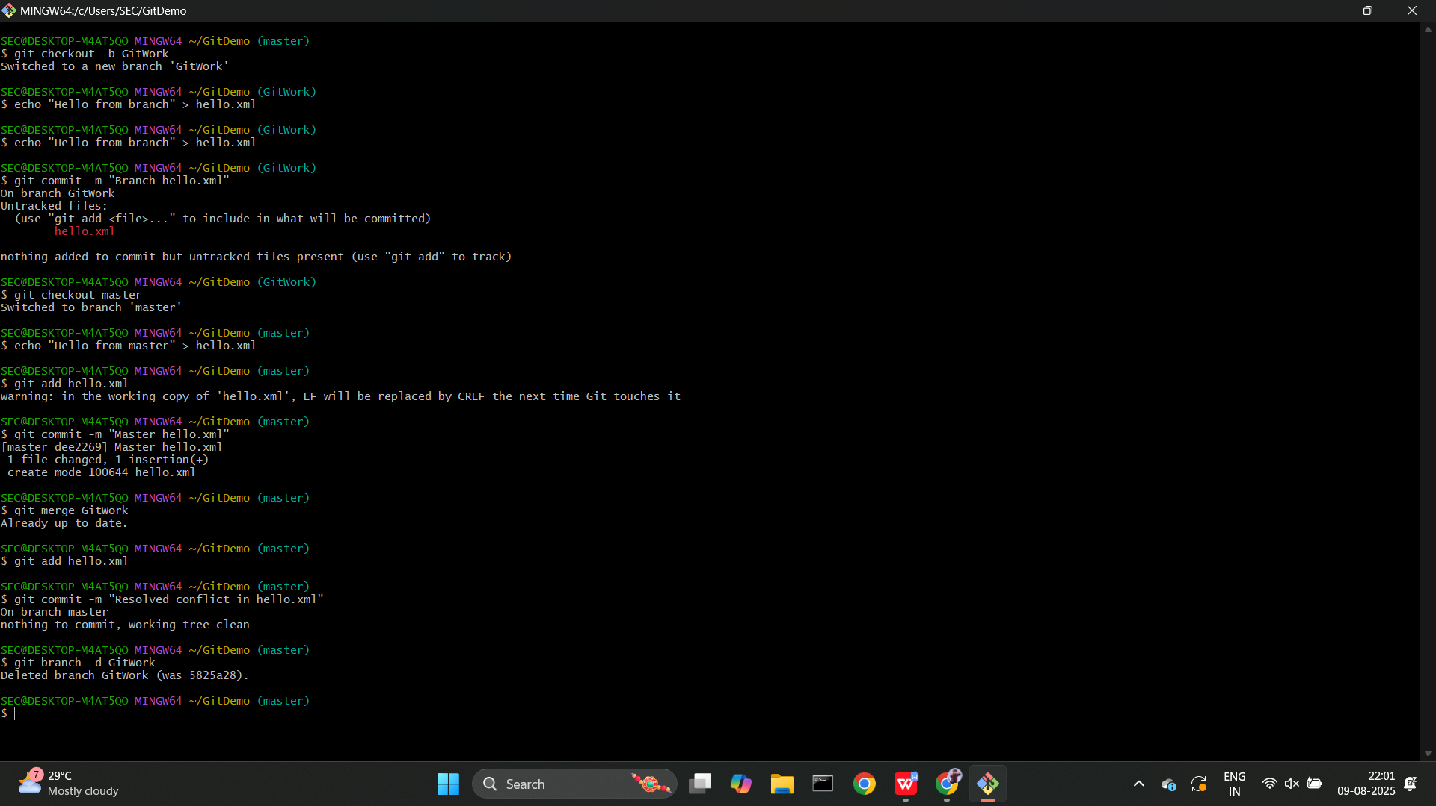

Summary of what I did:

Created conflicting changes to the same file in master and branch 'GitWork', attempted to merge, resolved the merge conflict using a merge tool, committed the resolution, and cleaned up the branch.